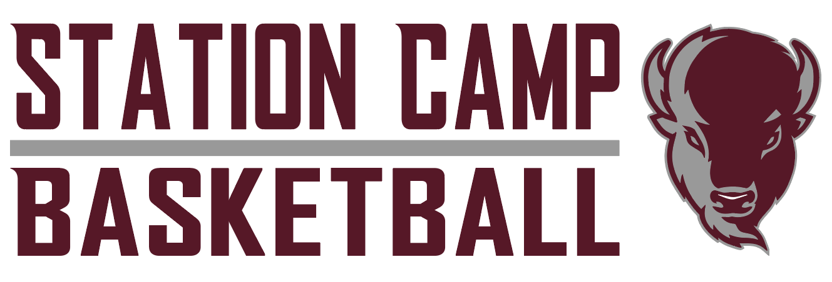

#2 | Ben Ogan | 6’2” | Junior | G/F
#3 | Matthew Massey | 6’3” | Junior | G/F
#5 | Brandon Fields | 5’9” | Sophomore | Guard
#10 | Anthony Eidson | 5’10” | Junior | Guard
#11 | Sam Corey | 6’2” | Junior | G/F
#14 | Braxton Bess | 5’8” | Sophomore | Guard
#21 | Maddox Schlagenhaft | 6’1” | Sophomore | Forward
#22 | Blake Lancaster | 6’2” | Junior | Guard
#23 | Grady Parsons | 6’3” | Junior | G/F
#30 | Kenton Major | 6’5” | Senior | Forward
#33 | Nate Meadows | 6’2” | Junior | Forward
#34 | Sam Bailey | 6’5” | Senior | Forward
 | Seth Bailey |  | Freshman | Forward
 | CJ Holt |  | Freshman | Forward
 | Carter Kirk |  | Freshman | Guard
 | Mason Murray |  | Freshman | Forward
 | Nate Parsons |  | Freshman | Guard
 | AJ Pettway |  | Freshman | Guard
 | Ty Thurston |  | Freshman | Guard

Head Coach: Seth Massey
Assistant Coaches: Bryce Gooch, Andrew Perry, Ryne Sexton
Student assistant: Noah Briskie
Managers: Charlie Beam, Steven Whitsitt, Seth Lawler

